For the next few classes, we would work on Keras as the deep learning tool. It is strongly recommended to pursue the installation in a 64 bit system, instead of a 32 bit one. Also, please ensure you have Git installed in your system. Hence, request you to get it installed in your system before the next class. The following steps demonstrate installation of Keras. For a more detailed guide, please visit:

<https://keras.io/#installation>

**Installation Steps**

Step 1: Open Spyder and navigate to Tools -> Open Command Prompt

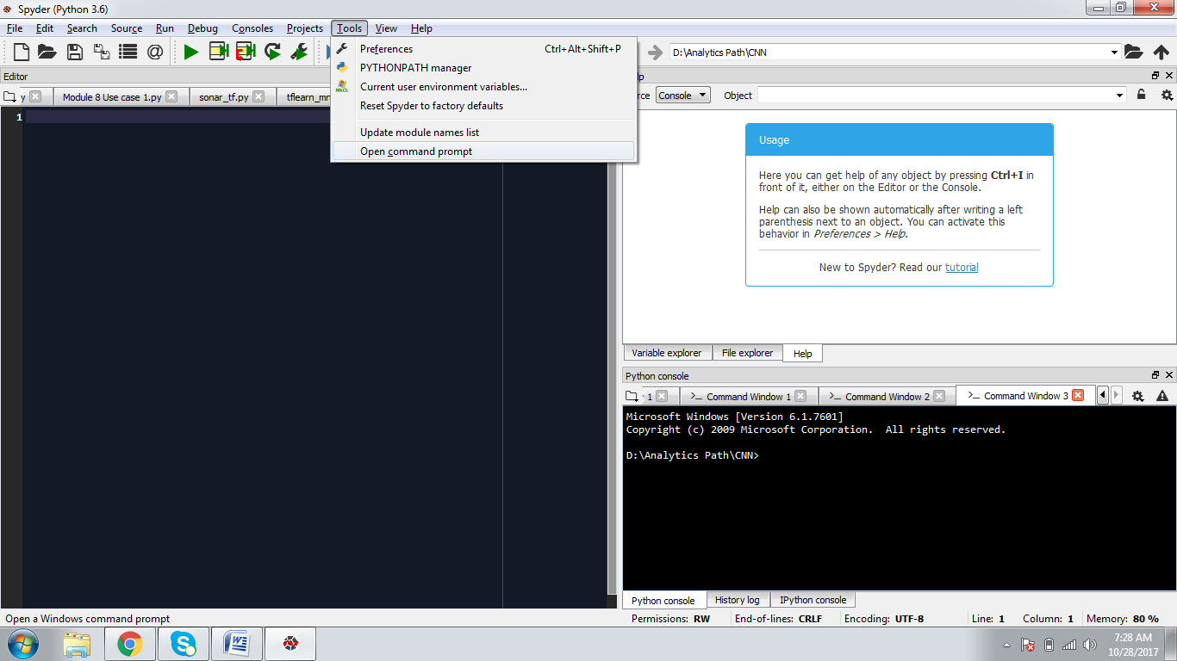

Step 2: First Install Theano using:

*pip install --upgrade --no-deps git+git://github.com/Theano/Theano.git*

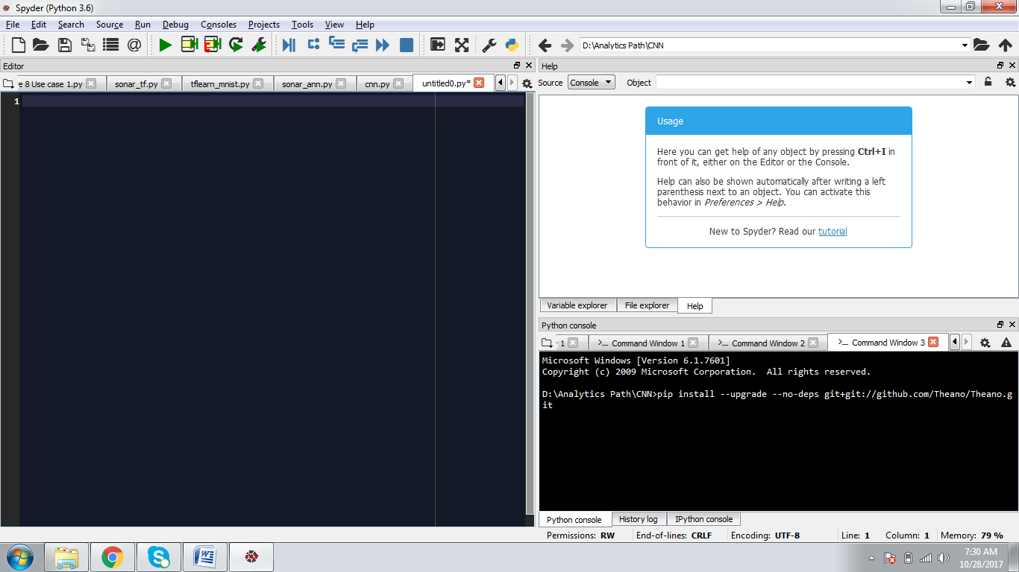

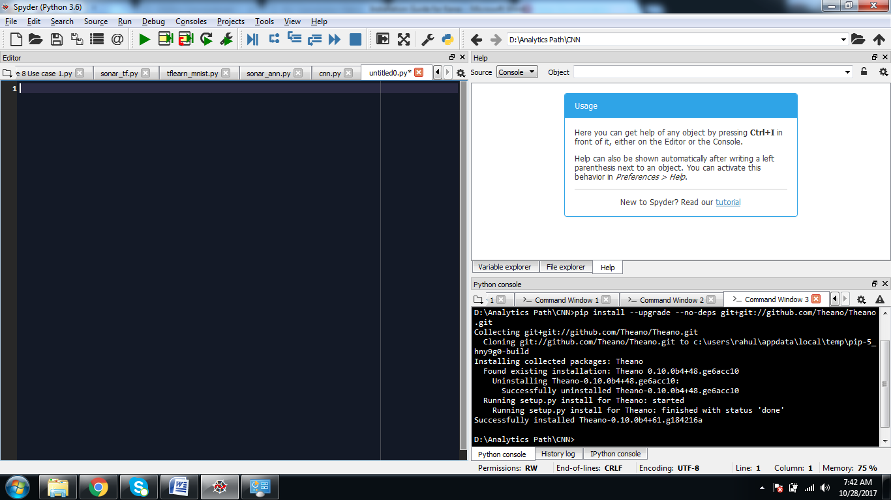

Step 3: Once Theano is installed, install Tensorflow using

*pip install tensorflow*

Step 4: Finally, install Keras

*pip install --upgrade keras*